Topic 2
Content-language Relationships:
Content-obligatory Language and Text Structures

Key concepts to learn

Concept 1: Content-obligatory language is language essential (i.e. obligatory) to the content. We can think of content-obligatory language as consisting of language at two levels. First, the word level: content-obligatory vocabulary, which is mainly subject-specific vocabulary. Second, the sentence / text level: the language of knowledge structures, which is needed to represent the knowledge relationships.

Concept 2: Content-obligatory language at the sentence / text level can be identified in the form of text structures. Text structures are language organised in certain forms (structures) to represent the relationships (structures) organised in knowledge structures.

Concept 3: Each knowledge structure has its own corresponding text structure(s).

Concept 4: Subject concepts involving knowledge structures and nominalisations represented in texts / text structures have to be deconstructed / unpacked for students to help them understand the knowledge relationships.

Lecture: Content-obligatory language (i.e. language of knowledge structures) and text structures

We mentioned in Topic 1 that knowledge structures have their related language forms and text structures. Specific language forms and text structures of each knowledge structure are obvious at both the sentence level and the text level. In this topic, we are going to examine the specific sentence structures and text structures of different knowledge structures. We are going to examine how different knowledge structures are represented in different sentence structures and text structures and how language is used to represent meanings in different knowledge structures. We are also going to examine why these knowledge structures and their corresponding language are important in the subject areas.

To understand why the language of knowledge structures is important in the subject areas, we can first think of the concept of content-obligatory language. Content-obligatory language means language essential (i.e. obligatory) to the content i.e. without using these particular language forms, the content cannot be represented. For example, we cannot represent the process of photosynthesis without using the words essential to representing the subject concepts involved (i.e. content-obligatory vocabulary e.g. photosynthesis, oxygen, carbon dioxide, water, chlorophyll, sunlight). However, only using the content-obligatory vocabulary cannot represent the knowledge relationships involved in the process of photosynthesis. The language of process (a knowledge structure) is also needed to represent the relationships involved in a process (mainly sequence and cause-effect).

Content-obligatory language therefore consists of language at two levels: vocabulary and sentence / text. Content-obligatory vocabulary represents the subject concepts and content-obligatory language represents the knowledge relationships between subject concepts. Content-obligatory vocabulary is subject-specific vocabulary i.e. vocabulary used only in a particular subject or used with a particular meaning in a subject. For example, photosynthesis is a subject-specific vocabulary to science; solution as a subject-specific vocabulary in mathematics means an answer and in chemistry means a mixture of a solute and a solvent. Content-obligatory language (at the sentence and text level) is the language of the knowledge structure in which the content is organised (representing the knowledge relationships involved). For example, we represent the process of photosynthesis with both the subject-specific vocabulary of photosynthesis and the language of the knowledge structure of a process. A process involves a sequence of events that are linked in a cause-effect relationship, therefore the language of sequence and the language of cause-effect is needed. This language has to be organised in a particular text form / text structure to represent how the content is organised. The text structure of the knowledge structure of process is called a process explanation, reflecting the sequence and the cause-effect relationships. Each knowledge structure has its own corresponding text structure(s).

English medium teachers need to have an understanding of how language is used to represent meanings in organised ways in their subject. Without this knowledge, they cannot use the language appropriately to explain the knowledge relationships involved in the subject content and they will not be able to teach students how to use English appropriately to express their understanding of subject meanings. Students need to know how to produce longer and better-developed written texts in English to be able to demonstrate and develop their content knowledge in English medium learning.

We are going to look at the content-obligatory language and text structures of science texts by analysing four different but common text structures in science in the following aspects:
- The purpose of a text which signals the knowledge structure represented;
- The structure of the text: how many parts there are and how the parts are related to each other;
- Typical language forms including content-obligatory vocabulary.

We are also going to see how the use of nominalisations and noun phrases are specific to academic texts and how they create problems for students. We will look into how teachers can deconstruct / unpack subject concepts involving knowledge structures and nominalisations to explain these concepts clearly to students.

Nominalisation is the process of changing a verb (that represents a concrete action in real life e.g. move, transpire) into a noun (that represents an abstract concept that exists in human brain as knowledge e.g. movement, transpiration). When we try to make sense of what is happening in the environment, we can turn concrete actions into abstract concepts. Then we can further explain and relate these abstract concepts to one another. For example, when we learnt that there is a cause-effect relationship between the two concrete actions of ‘air moves’ and ‘plants transpire’, we need to turn ‘air moves’ into air movement and ‘plants transpire’ into transpiration (of plants) so that we can say that ‘the transpiration rate increases with increased air movement’. This simple sentence (subject – verb – complement) represents very complicated concepts that can only be represented in many more sentences if we do not use nominalisations. Just putting together the two clauses into, for example, ‘when air moves, plants transpire’ does not represent the complicated meaning involved. However, to help students understand the complicated concepts involved in a sentence such as ‘the transpiration rate increases with increased air movement’, the teacher needs to deconstruct / unpack it to reveal the underlying relationships. The lecturer will show you how to deconstruct / unpack this.

A noun phrase consists of a head noun extended by a pre-modification (e.g. an adjective) and/or post-modification (e.g. a prepositional phrase, a relative clause).

The four common text structures we are going to analyse are:
- Information Report
- Process Description
- Process Explanation
- Comparison-contrast

The following table shows the knowledge structures and the corresponding text types / structures and typical language use. Note that the same knowledge structures are represented in different text types / structures:

Text type & structure: Parts  [^ = followed by; ( ) = optional] | Knowledge structures | Typical language forms
Information Report  Definition of phenomenon^  Specific descriptions  OR  General classification^  Specific descriptions  Purpose: To give information or to define a phenomenon | Classification  Definition  Description | Language of classification:  - passive verbs: is/can be categorized/ divided/classified into…  - active verbs: include, consist of, contain  - species nouns: groups/types/classes/ kinds/categories of…  Language of definition:  - active verbs: is, means, refers to  - passive verbs: is called, is known/ defined as, is formed by  - nouns: a process of, the meaning/ definition of  - relative clauses: which/that/where + verb  - if-clause, when-clause  Language of description:  - prepositional phrases  - adjectival phrases
Process Description  Identification / Definition of the process / phenomenon to describe^  Description sequence  Purpose: To tell the sequence of events in a process | Sequence  Description | Language of sequence/process/route:  - verbs: follow, is followed by  - nouns: step, stage  - verb + prepositional phrase → route  - prepositional phrases  - conjunctions: before, after, prior to, when  - connectives: first, second, firstly, secondly, next, then, finally  - when-clause
Process Explanation /  Factorial Explanation  Identification / Definition of the process / phenomenon to explain^  Explanation sequence/Explanation  Purpose: To explain the cause-effect relationships in the sequence of events within a process | Cause-effect  Sequence | Language of sequence  Language of cause-effect:  - causal verbs: cause… to…, result in, produce, bring about, lead to, increase [& verbs (make, produce, remove, increase)]  - causal nouns: the result of, the reason of, the consequence of, the cause of, the effect of  - causal connectives: therefore, so, consequently  - causal conjunctions: since, because, so that  - causal clauses: when-clause, if-clause
Comparison-contrast  Statement of comparison^  Points / Details of comparison^  (Summary of comparison)  Purpose: To compare two or more entities | Comparison-contrast | Language of description  Language of comparison:  - parallelism  - negation (not)  - verbs: differ from, distinguish, is the same as  - nouns: differences, similarities  - adjective phrases: compared with, different from, same as, similar to  - comparatives, superlatives  - conjunction: both, and, but, not only … but also, whereas, while  - connective (additive, contrastive): moreover, in addition, however, nevertheless
Procedure  Goal^  Method / Steps^  (Results / Evaluation)  Purpose: To instruct how to do something | Sequence | Language of instruction:  - imperatives (to tell what to do)  - quantifiers (to tell how much/many is needed)  - prepositional phrases (to tell when, where and how to do things)
Persuasion  Thesis^  Arguments^  Reiteration  Purpose: To persuade / argue for some points of view | Evaluation | Language to tell views:  - Modality (e.g. should)  - Connectives (additive, adversative)  Language to give evidence:  - Language of cause-effect  - Language of exemplification
Discussion  Statement of the issue^  Arguments for and against^  (Recommendation / Restatement of the issue)  Purpose: To discuss some points of view | Evaluation  Comparison-contrast | Language to tell views:  - Modality (e.g. may)  - Connectives (additive, adversative)  Language to give evidence:  - Language of cause-effect  - Language of comparison-contrast  - Language of exemplification
Recount  Orientation / Topic^  Events in time order^  (Evaluation)  Purpose: To recall past events | Sequence | - Verbs in past tense  - Prepositional phrases to tell when, where and how

Workshop: Content-obligatory language (i.e. language of knowledge structures) and text structures

Activity 1: Identifying the knowledge structures and language use in textbook texts
The following are some extracts of texts from local science textbooks. Use the information from the table above to:
- identify the knowledge structure(s) represented;
- identify or suggest a graphic to represent the knowledge structure(s);
- circle the content-obligatory vocabulary;
- underline the language of the knowledge structure(s).

Text 1
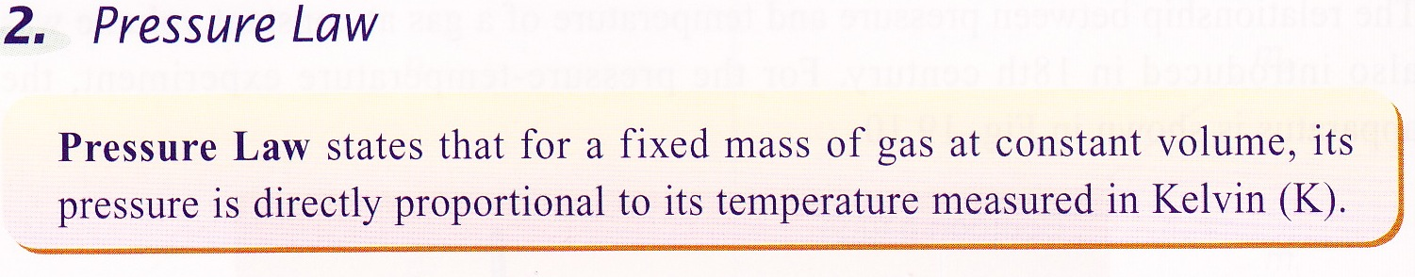

Text 2
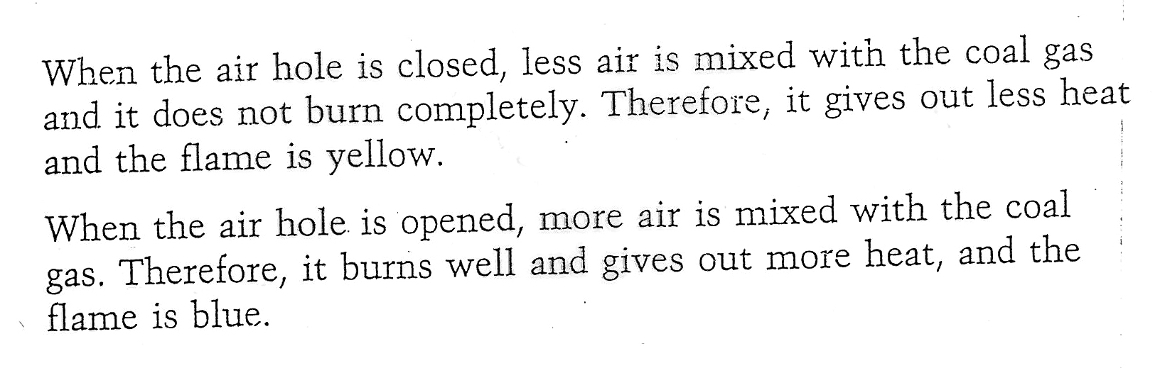

Text 3
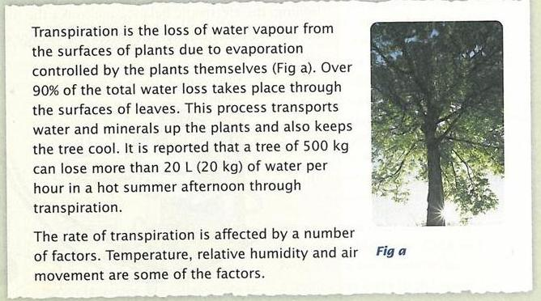

Text 4

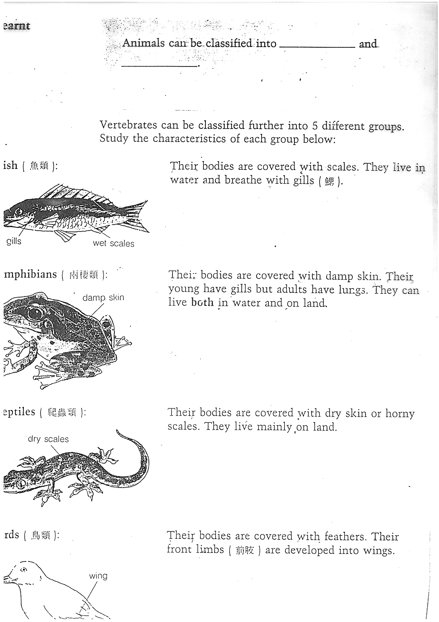

Text 5

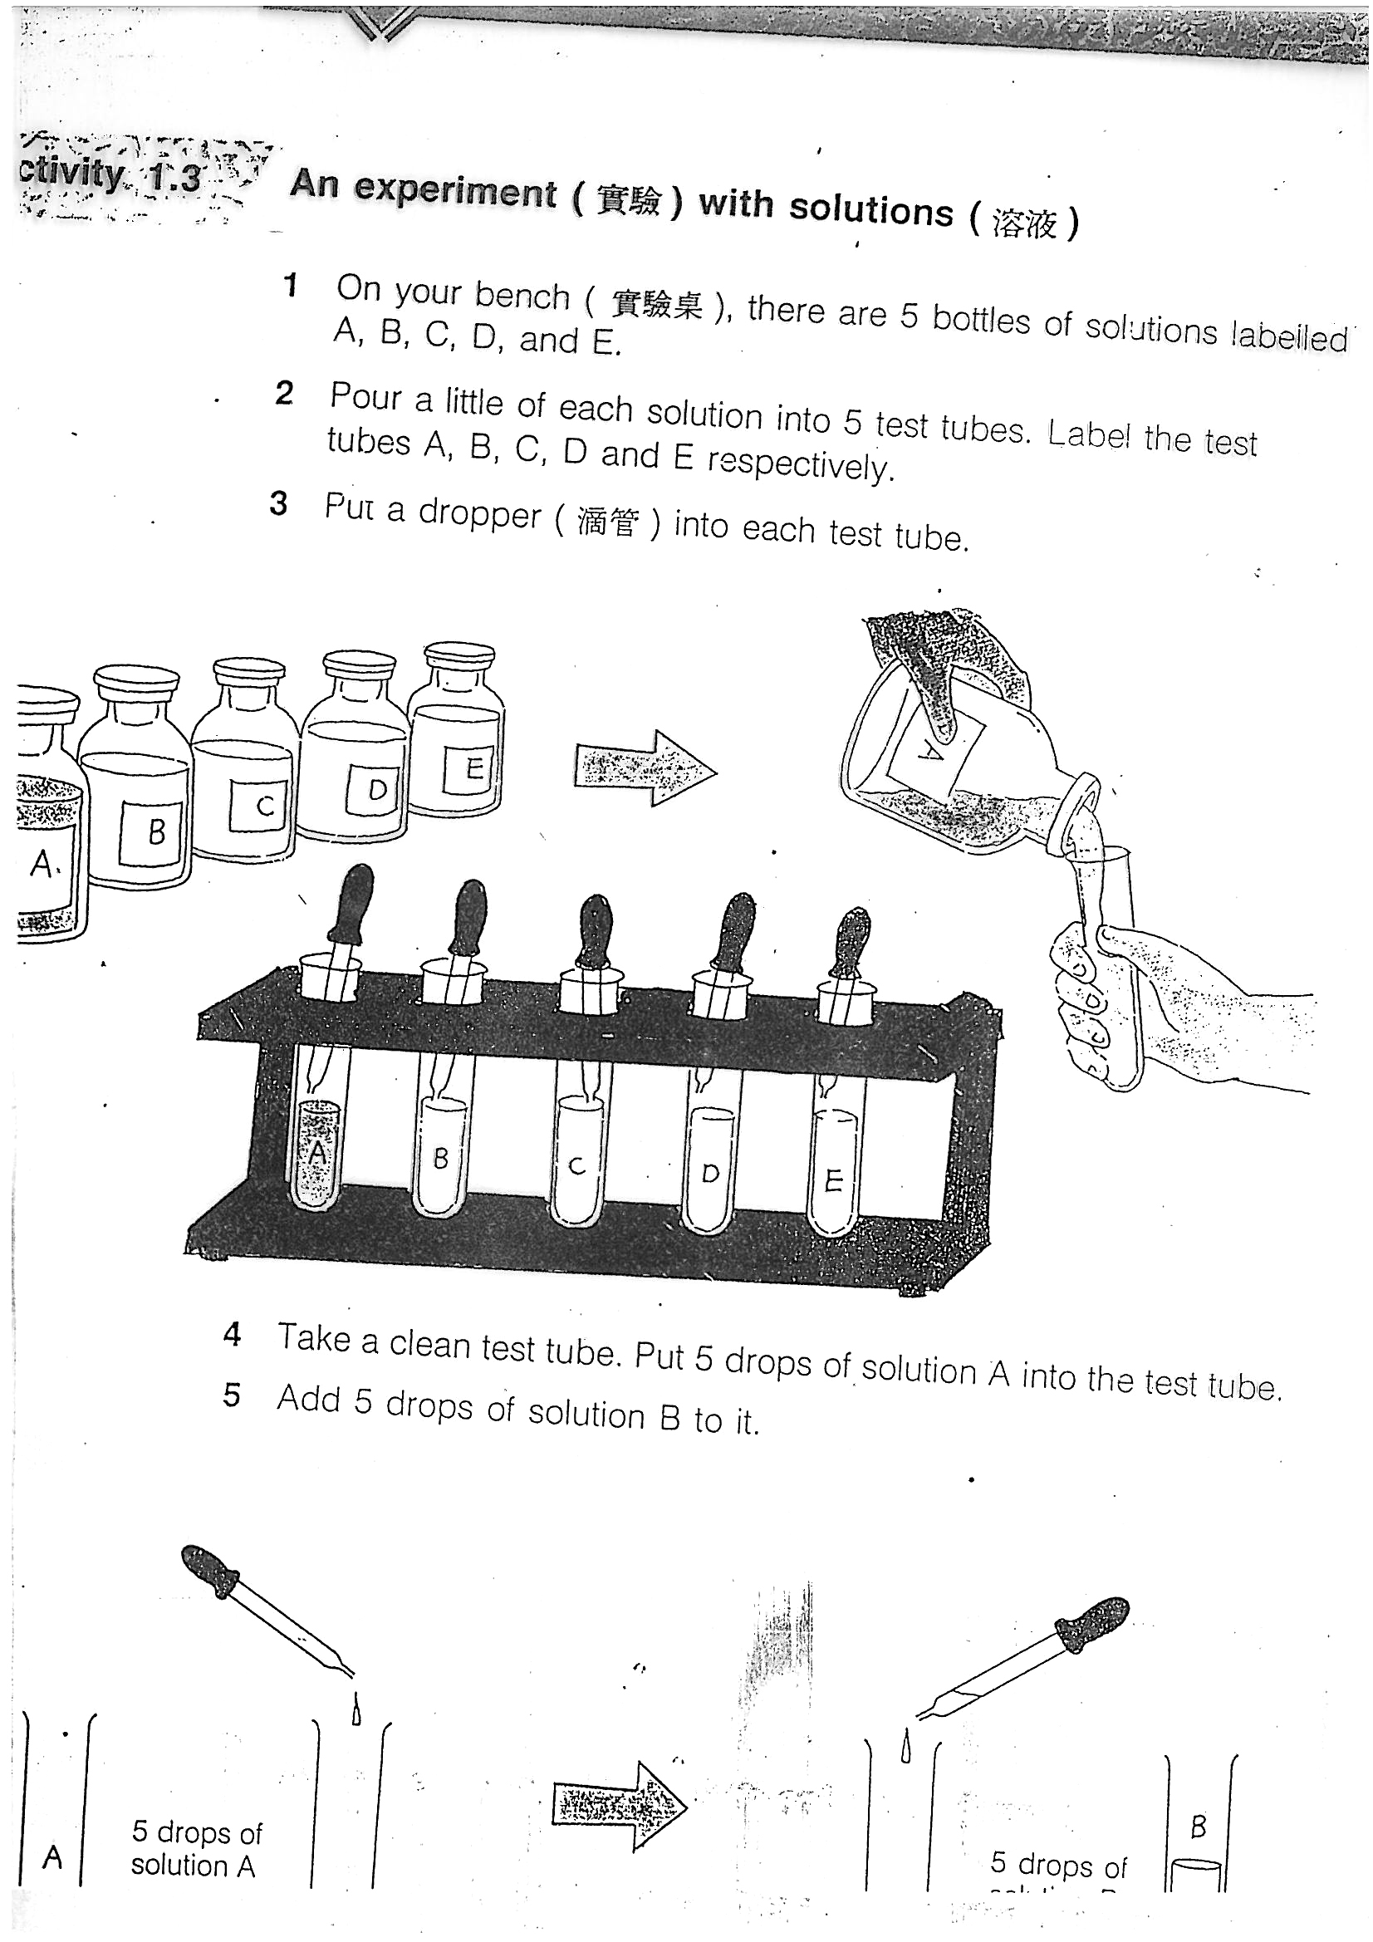

Text 6
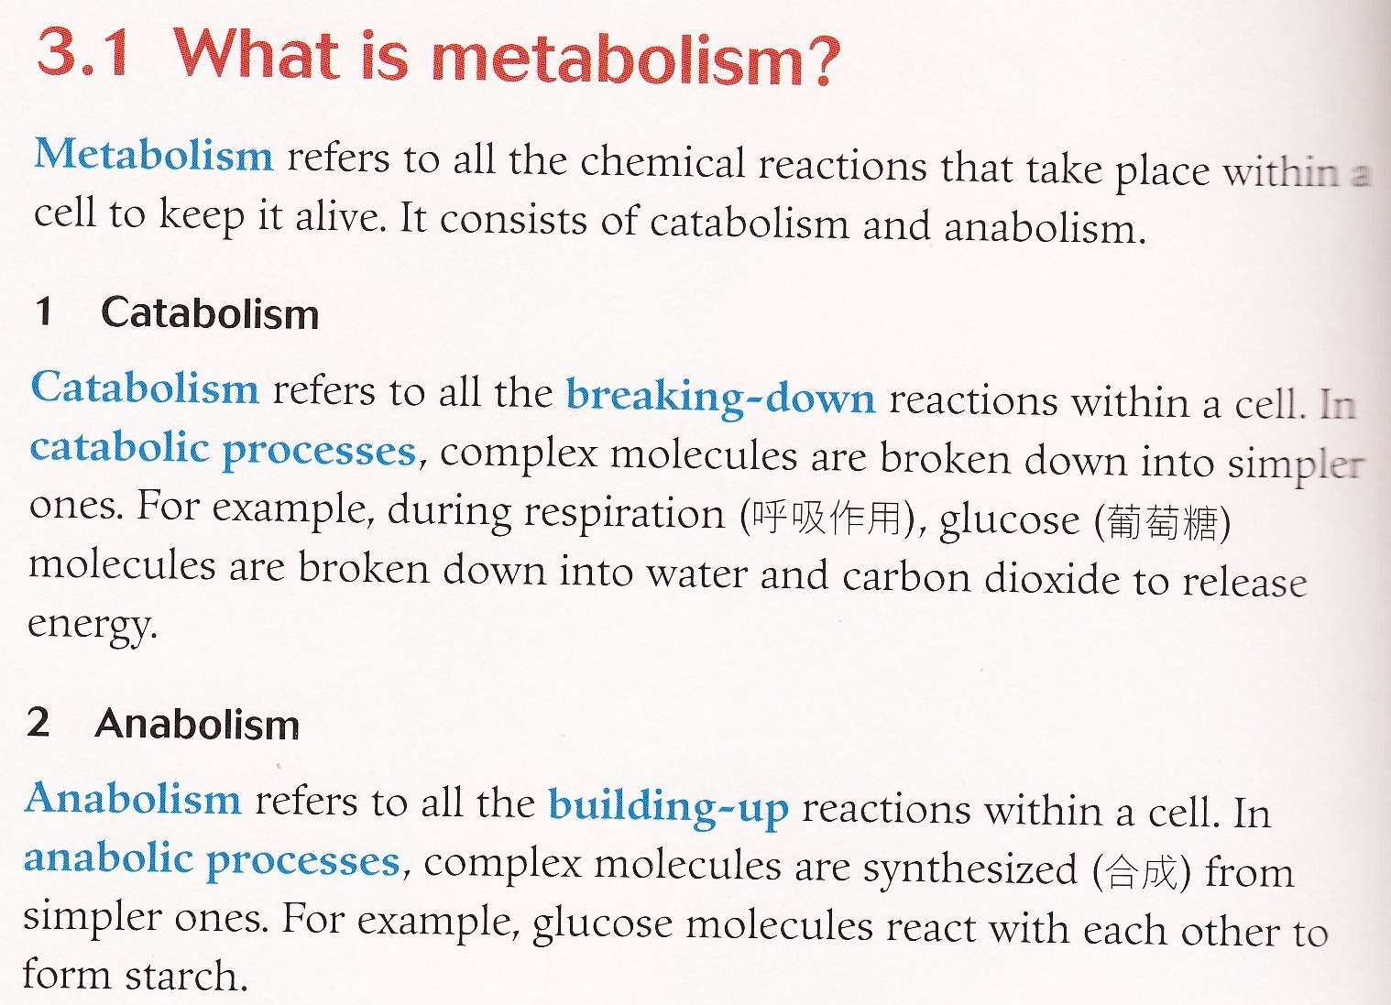

Text 7

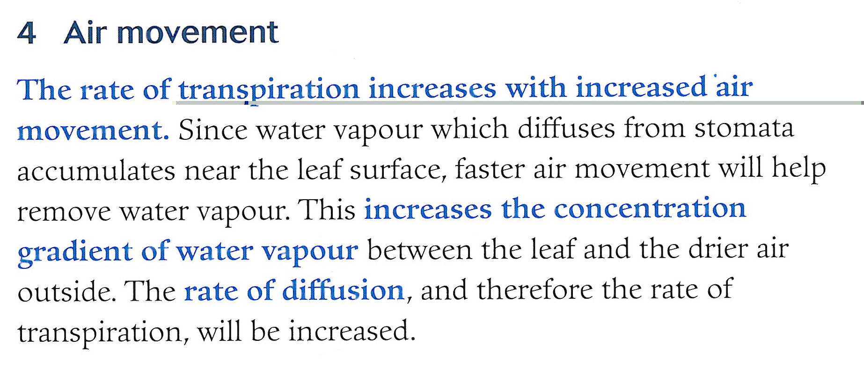
[from Pang & Cheung, 2003, p.29]

Text 8

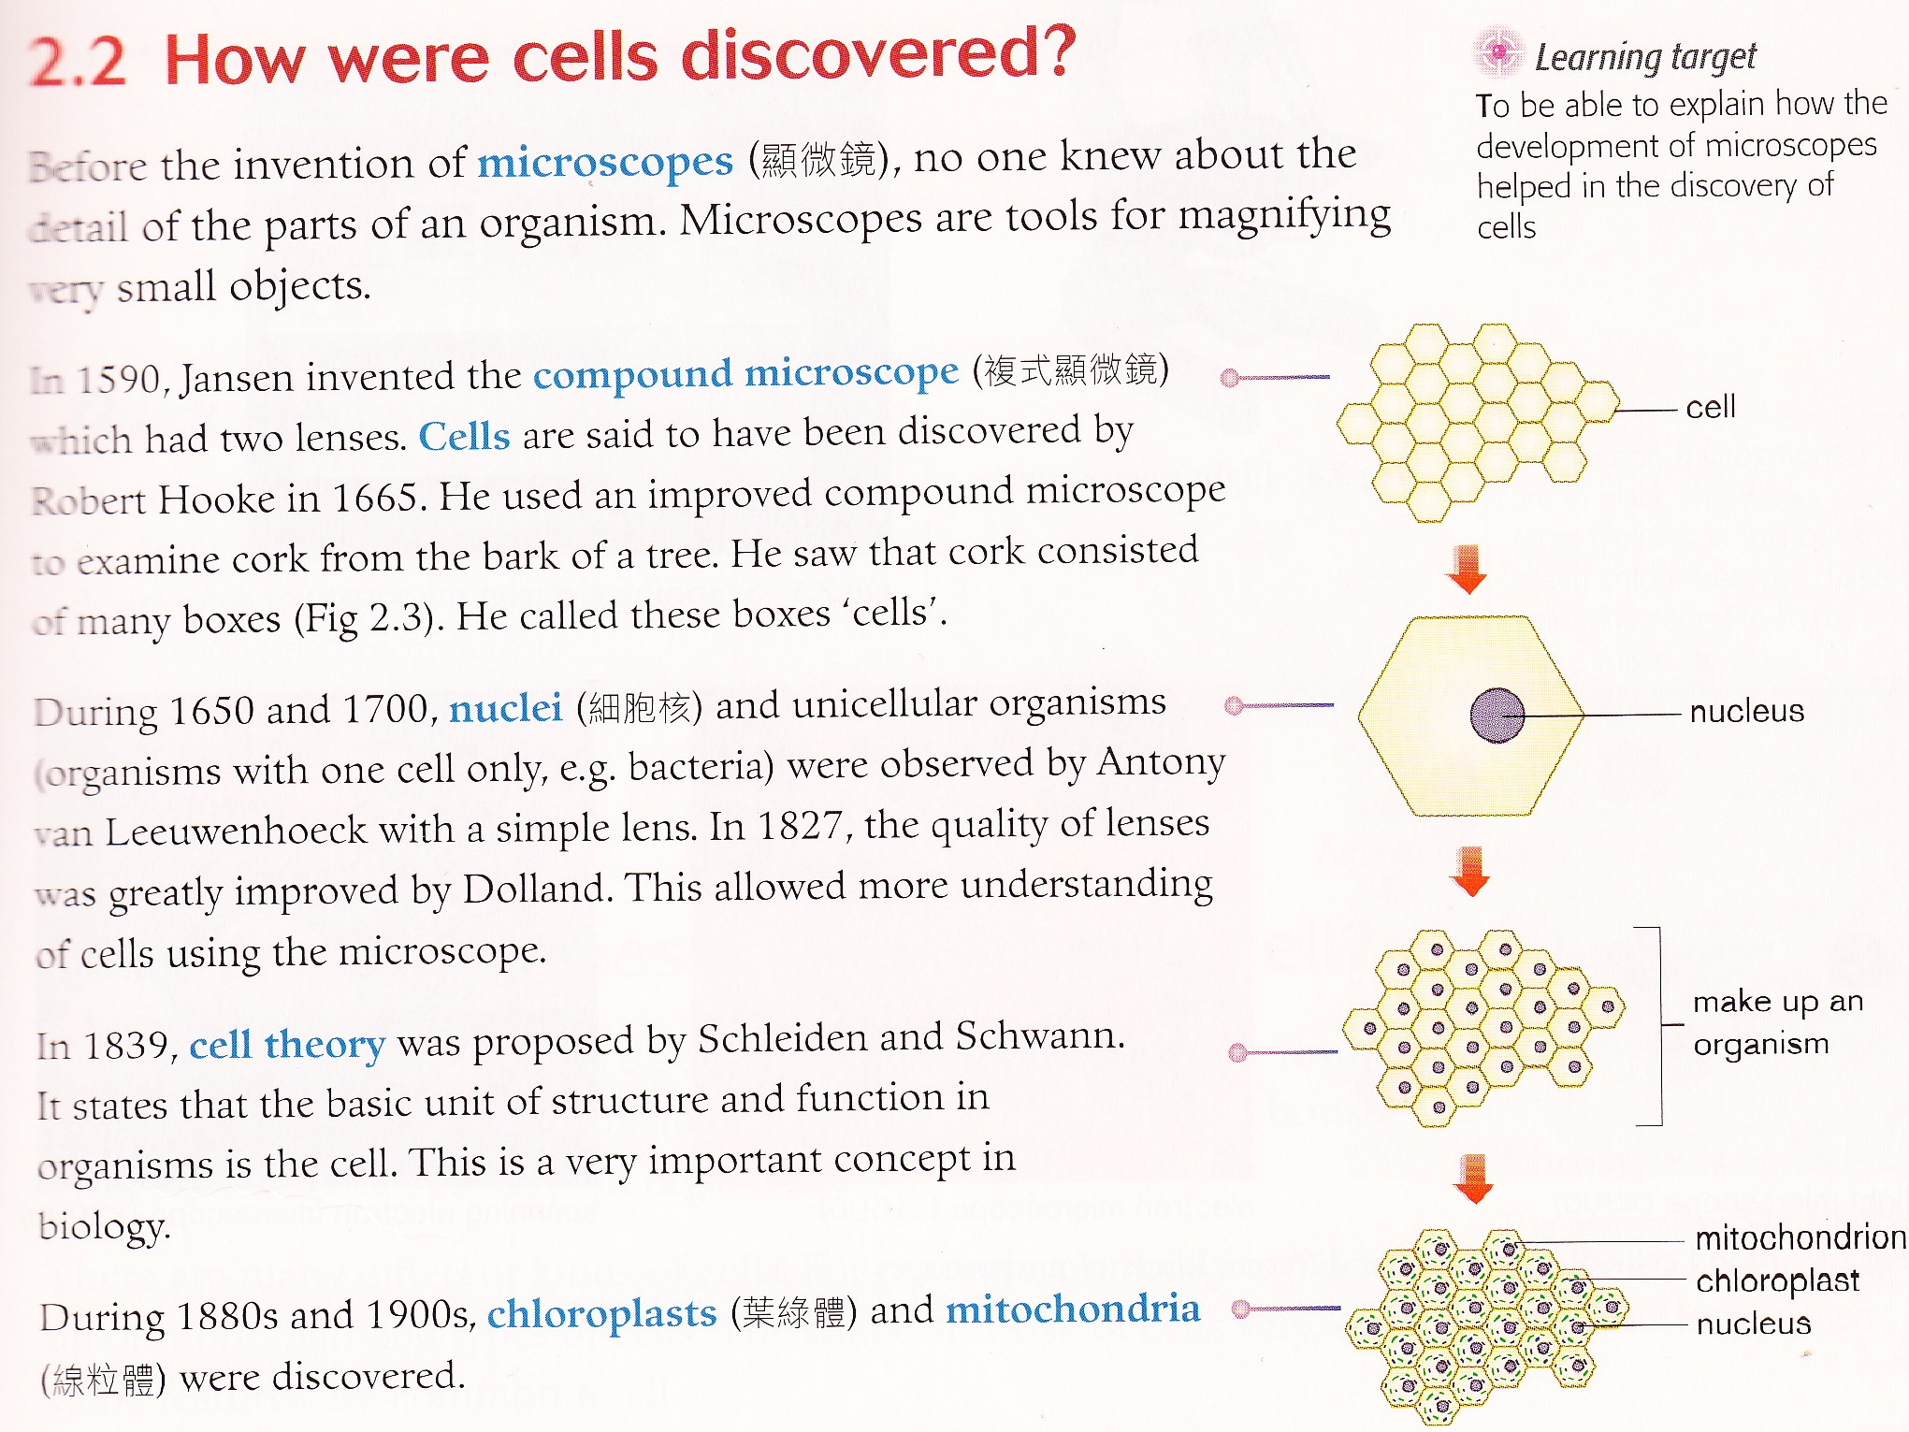

Activity 2: Analysing 4 different text types & structures in science texts
Follow the instructions below each text to identify:
- the purpose and the knowledge structures;
- the text type and the text structure;
- the language use.
Use the knowledge structures and text structures table to help you.

Text 1
What are living things made up of?
The basic units of living things are cells. Cells make up all living things just like the plastic toy bricks making up a toy house.

Some tiny living things, such as Amoeba and bacteria, are made up of only one cell. They are called single-celled organisms.

Other living things, such as plants and animals (including humans), are made up of more than one cell. For example, the human body is made up of about 100 trillion (100,000,000,000,000) cells, of more than 200 types. Each type of cell has a different shape and special functions.
[taken from Understanding Integrated Science 1A, Aristo, pp.136-7]

- Purpose of the text
Read through the text to identify the main purpose of the text.
a. What does the text aim to do? What is the key message in the text?
_________________________________________________________________
b. What knowledge structures are represented in the text?
_________________________________________________________________

- Structure of the text
Read the text again to identify the purpose of each paragraph. Use a verb (that can be related to a knowledge structure) to state the purpose of each paragraph.

Paragraph 1: to ____________________________________________________
Paragraph 2: to ____________________________________________________
Paragraph 3: to ____________________________________________________

Paragraph 1 plays a different role from Paragraphs 2-3. Paragraph 1 ________________ (start with a verb that relates to a knowledge structure) while Paragraphs 2-3 _________ __________________________ (start with a verb that relates to a knowledge structure).

We call this type of text an _____________________________, which consists of two parts:
Part 1: ________________________________
Part 2: ________________________________

The specific description gives details of / more information about a class of entities.

- Typical language forms
Circle all the content-obligatory vocabulary.
Draw a cross on all the language of definition.
Underline all the language that describes / gives further information.
Put in a rectangle the language that gives examples.

What kind of language is left unmarked?

An information report requires mainly the use of the language of _____________ and the language of _______________ (refer to the underlined words above).

Text 2
Respiration: Ventilation of the lungs
Ventilation of the lungs is the process by which air is inhaled and exhaled. This process is the first stage in respiration.

When we inhale, air containing 21% oxygen enters the respiratory system through the mouth and the nose. The air passes through the larynx and the trachea into the two bronchi, which divide into many bronchioles. The air passes into these bronchioles, which connect to tiny sacs called alveoli. Gaseous exchange takes place in these alveoli. When we exhale, air containing less oxygen but much more carbon dioxide goes back from the alveoli to the bronchioles and then to the bronchi. From the bronchi, air goes back to the trachea and the larynx and then goes out of the respiratory system through the mouth and the nose.

- Purpose and knowledge structure of the text
The purpose of the text is to ____________________________________________
The main knowledge structure represented is ______________________________
A possible graphic to represent the knowledge structure is ____________________

- Structure of the text
Paragraph 1: to ______________________________________________________
Paragraph 2: to ______________________________________________________

There are two parts in this text:
Part 1: ______________________________ (Paragraph 1, which defines the phenomenon / process to be described)
Part 2: ________________________________ (Paragraph 2, which describes the sequence of events in the process)

We call this type of text a ______________________________, which differs from a process explanation in that there are no _______________________ relationships in a process description.

- Typical language forms
Circle all content-obligatory vocabulary.
Put in a rectangle the language of definition.
Put in a square all the verbs that describe what happens in the process of ventilation of the lungs.
Draw a line across all the prepositional phrases that describe the direction of events.
Put in brackets all relative clauses (a clause started by which or that) that provide more detailed description of a key entity in the topic.

What other language is left?

A process description requires the use of the language of _____________________ and the language of _____________________.

- Nominalised words / phrases; noun phrases (and deconstructing / unpacking and chunking)
Write down the two nominalisations used in the text:
_________________________________________________
Underline the noun phrases used in the text and circle the head noun in each one. Chunk up the most complicated noun phrase.

Deconstruct / Unpack one of the nominalisations:
_______________________________________________________________________
_______________________________________________________________________
_______________________________________________________________________
_______________________________________________________________________
_______________________________________________________________________
_______________________________________________________________________

Text 3
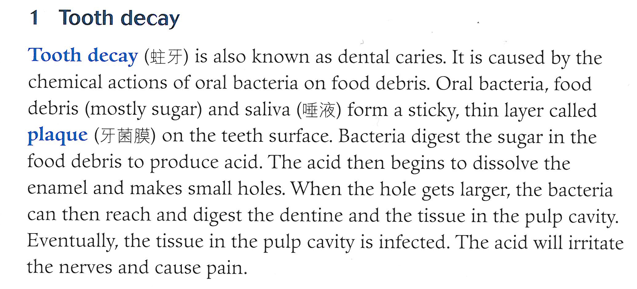
[from Pang & Cheung, 2003, p.93]

- Purpose and knowledge structure of the text
The purpose of the text is to ____________________________________________
The main knowledge structure represented is ______________________________
A possible graphic to represent the knowledge structure is ____________________

- Structure of the text
Sentences 1-2: to ____________________________________________________
Sentences 3-8: to ____________________________________________________
There are two parts in this text:
Part 1: ________________________________ (Sentences 1-2, which identifies / defines the phenomenon / process to be explained)
Part 2: ________________________________ (Sentences 3-8, which explains the cause-effect relationships in the sequence of events involved in the process).

We call this type of text a ______________________________, which differs from a process description in that there are ___________________ relationships between the steps in the process.

- Typical language forms
Circle all content-obligatory vocabulary.
Put in a rectangle the language of definition.
Put in a square all the verbs that describe what happens in the process of tooth decay. What kind of verbs are they?
Put in a triangle all the connectives used. What kind of connectives are they?
Underline all noun phrases that provide more detailed description of a key entity in the topic.

What other language is left?

A process explanation requires the use of the language of ____________________ and the language of _____________________.

- Noun phrases (deconstructing / chunking)
Underline the noun phrases in the text and circle the head noun in each one. Chunk up the most complicated noun phrase.

Text 4
Aerobic and anaerobic respiration in humans
Both aerobic respiration and anaerobic respiration take place in humans. Aerobic respiration requires oxygen. Anaerobic respiration does not.

Aerobic respiration takes place when there is enough oxygen supply. Anaerobic respiration takes place when we cannot have enough oxygen to produce the energy we need through aerobic respiration, for example, when we exercise. Aerobic respiration produces energy, water and carbon dioxide. Anaerobic respiration produces a much smaller amount of energy and it produces lactic acid instead of water. Lactic acid is poisonous, causing pains and cramps in our muscles.

Aerobic respiration and anaerobic respiration in humans take place under different conditions and produce different products according to the needs of the situations.

- Purpose and knowledge structure of the text
The purpose of the text is to ____________________________________________
The main knowledge structure represented is ______________________________
A possible graphic to represent the knowledge structure is ____________________

- Structure of the text
Paragraph 1: to ______________________________________________________
Paragraph 2: to ______________________________________________________
Paragraph 3: to ______________________________________________________

There are three parts in this text:
Part 1: Statement of comparison (Paragraph ____, which states that both aerobic and anaerobic respiration takes place in humans but under different conditions)
Part 2: Points of comparison (Paragraph ____, which compares the _____ aspects of differences between aerobic and anaerobic respiration)
Part 3: Summary of comparison (Paragraph ____, which is a summary statement of the comparison made in the text)

- Typical language forms
Circle all content-obligatory vocabulary.
Put in a rectangle all the language of comparison, including comparison connectives, adjectives (in comparative form), negation.
Underline all parallel but contrastive language use.

What other language is left?

- Nominalised words / phrases; noun phrases (and deconstructing / unpacking and chunking)
Write down two nominalisations used in the text:
____________________________________________
Deconstruct / Unpack one of the nominalisations:
_________________________________________________________________
_________________________________________________________________
_________________________________________________________________
_________________________________________________________________
_________________________________________________________________
Highlight the noun phrases in the text and circle the head noun in each one. Chunk up the most complicated noun phrase.

